Antonine Primary

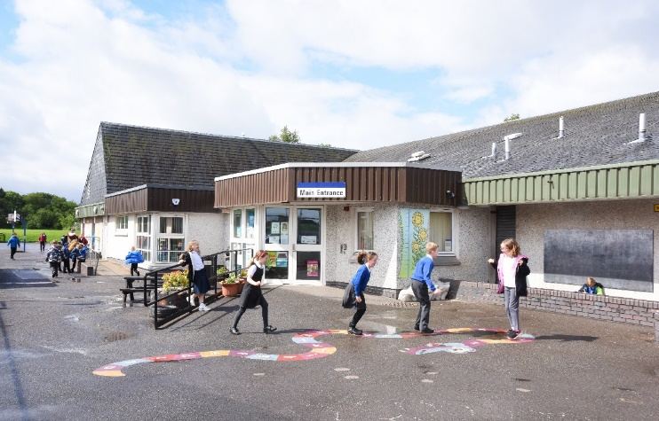

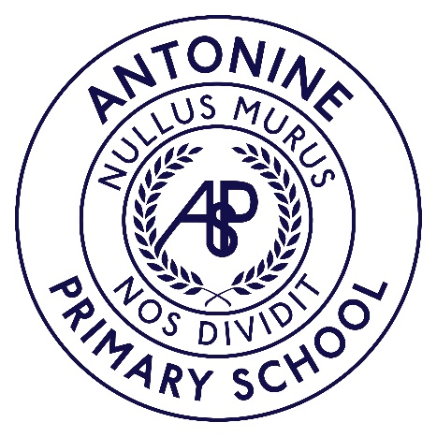

School Handbook
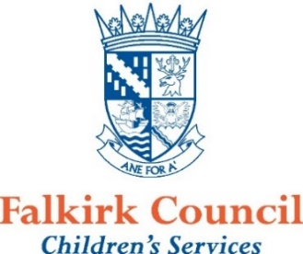
2026 - 2027

Contents

Foreword from the Director of Children’s Services

Service Pledges

Welcome from the Head Teacher

- Practical Information about the School

  - School Contact Details
  - Communicating with the School
  - School Policies

- Parental Involvement in the School

  - School Ethos

- School Curriculum

  - Assessment and Reporting your Child’s Progress

- Support for Pupils

  - Transitions – Moving to a New School or Leaving School

- School Improvement

A Foreword from the Director of Education
Session 2026–2027
This handbook contains a range of information which we hope will be helpful to you and your child. It offers an insight into the life and ethos of the school, along with advice and guidance to support you in your role as a key partner in your child’s education.

Falkirk Council is committed to working closely with parents and carers to enhance engagement and ensure strong home-school partnerships. One of the most effective ways to get involved is through the school’s Parent Council. Parent Councils are independent bodies that work with schools to support improvement, contribute to key decisions and represent the views of parents so helping to shape priorities and enrich the educational experience for all young people.

Throughout the school year, there will be opportunities to discuss your child’s progress with their teacher(s) and via the ‘Progress’ reporting system/app. You can also stay informed about school news and activities by following your school’s social media channels, as well as central accounts like @ConnectedFalk, and @falkirkcouncil, where we regularly share updates and celebrate success.

We are proud that Falkirk Council continues to support the Connected Falkirk digital learning programme. Thanks to this investment, every young person from P6 to S6 has their own personal learning device, enabling access to high-quality digital learning and direct teacher feedback anytime, anywhere. Not every child in Scotland has this opportunity, so we encourage you to ask your child to show you their learning - it's a great way to stay involved and celebrate their progress.

Since taking up the post of Director of Education in May 2024, I have made it a priority to spend time in our schools and centres and I continue to be regularly in and out of establishments across the area. Meeting staff, pupils and parents, and seeing first-hand the excellent work being done, is one of the most important and rewarding parts of my role. Across Falkirk, we are rightly proud of our strong levels of attainment and achievement and of our record numbers of young people progressing into positive destinations after leaving school.

We also take great confidence from the strong evaluations received from both HMIe and the Care Inspectorate, which highlight the quality of our learning environments, the professionalism of our staff and the care and support we offer children and families. Alongside the Heads of Education and the wider central team, I am working in close partnership with Headteachers to build on this success and secure the very best outcomes for every young person in Falkirk.

I trust this handbook will provide you with useful information about your child’s school. If you have any questions, please contact the Headteacher of your child’s school, who will be happy to help.

With very best wishes.

Jon Reid
Director of Education
Falkirk Council
Footnote: If you want a printed copy of this handbook, please ask the school.
It may be possible to offer some assistance in helping to translate all or part of this handbook to parents whose first language is not English. Enquiries should be direct into the Communications Officer for Education Services (email: EducationServices@falkirk.gov.uk)

Disclaimer
The information in this school handbook is considered to be correct at the time of publication (December 2025). However, it is possible that there may be some inaccuracy by the start of the school term in August 2026.

Curriculum for Excellence – Learning to Achieve

Learning Entitlements

In addition to the entitlements of Curriculum for Excellence our education provisions will reflect local needs and circumstances. Therefore, at different stages of their education, our learners will have opportunities to:

- Link aspects of their learning to the local environment and its heritage
- Participate on a residential experience where possible
- Participate in arts, sports and cultural events
- Participate in integrated, hands-on learning for sustainability, fostering global citizenship, critical thinking, and lifelong skills
- Participate in outdoor learning experiences
- Equitable access to technology for learning, including digital devices, internet connectivity, and the development of digital literacy skills.
- Be consulted on and contribute to the decision-making process in school
- Access to vocational and work-based learning experiences that provide practical skills, industry exposure, and pathways to employment.
- Develop leadership and social skills through collaborative projects, extracurricular activities, and active participation in school and community initiatives
- Access learning experiences designed and / or delivered by relevant partners
- Reflect upon and be proactive in planning and making choices about their own learning
- Engage with learners in other countries where appropriate and demonstrate knowledge of their culture.

How can you help?
By law, you must make sure your child receives education.
As a parent, you can help your child by:

- Ensuring regular and punctual attendance
- Encouraging and facilitating home learning opportunities and study routines where appropriate
- Attending parent-teacher meetings/discussions and school events.
- Discussing school reports with your child
- Encouraging reading and educational activities outside of school
- Supporting participation in extracurricular activities and clubs
- Discussing what was learned at school and showing interest in their education.
- Setting high expectations and celebrating achievements
- Helping them develop good organisational and time-management skills
- Promoting healthy eating and adequate sleep at home
- Encouraging a positive attitude towards learning and school
- Collaborating with the school on individual education plans where appropriate
- Participate on a residential experience where possible

Throughout this handbook the term ‘parent’ has the meaning attributed in the Standards in Scotland's Schools Act 2000 and the Scottish Schools (Parental Involvement) Act 2006. This includes grandparents, carer or anyone else who has parental responsibility for the child.

Welcome from the Head Teacher

Welcome to our school handbook.

Antonine is a learning community where we aim to Get It Right for Every Child (G.I.R.F.E.C. Scottish Government). We teach children using the principles and philosophy underpinning a Curriculum for Excellence. It is a continuing process to encourage more learning through experiences to best ensure that children and young people are prepared for the complex world they will be living in when they leave school.
Children and young people are at the centre of our learning provision. Our aspiration is that they should all develop the four capacities to become: Successful Learners, Confident Individuals, Responsible Citizens and Effective Contributors. Our teachers and early years’ officers aim to provide learning and teaching of the highest standard, with learning experiences matched to the needs of the children.
We value parental involvement and want to work together as partners in your children's learning. We value your commitment to and involvement in the school community.

We have embedded “School Values” and at Antonine PS we encourage everyone to be Respectful, Happy, Resilient and Nurturing.

If you are new to the school or Early Learning and Childcare Centre we look forward to getting to know you; if you have been part of Antonine Primary School community for a while we thank you for your support.

Mrs Jacqueline McLaughlin
Head teacher
01324 503140
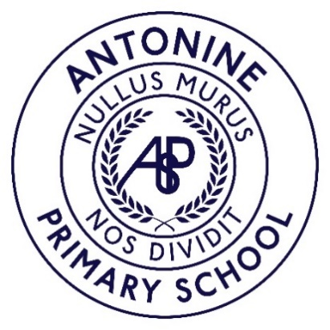


Welcome to the Antonine Primary School Handbook
This handbook offers an introduction to our school and a general overview of the education your child will be getting at school.

If you have any questions or would like any further information on any aspect of this handbook or the education of your child, please do not hesitate to contact me.

To make our handbook easy to use the information is divided into five different sections: -

Section One – Practical Information about the School
This section provides you with some background information on our school and our nursery. It tells you how our school day and school year are made up and how to contact the school if, for example, your child is ill.

This section deals with the practical aspects of your child’s attendance at our school.

It provides details on such things as:

- travelling to and from school
- school meals
- financial assistance with school clothing, transport and school meals
- school closures in an emergency or unexpectedly for any reason
- general supervision available for your child in the morning and at lunchtime
- wet weather details
- how the school communicates with parents
- how to complain if you are not happy about something.

As with any organisation, to ensure smooth running and appropriate maintenance of standards, a range of procedures and policies have to be implemented within our school.

This section gives an overview of the policies the school has in place. If you would like to see a full copy of these policies or to discuss them in more detail, please contact me. Most of these policies are available through links or pasted on the school or council website.

http://antonineps.schoolwebsite.scot/

- Clothing or uniform (PE Clothing)
- Health Statement / medicines

The school regularly updates parents via email and the school app.

Section Two – Parental Involvement in the School
Parental involvement is very important as we know it helps children do better in school.

This section contains information about how parents can be involved in supporting learning at home as part of a home – school partnership.

You can also find out more about the ethos of the school, what our values are and our aspirations for our pupils including how we celebrate pupil success, and links we have with partner organisations and the wider local, national and international community.

Lastly, it includes information on our Parent Teacher Association and Parent Council, how to contact them and how parents can get involved in the life and work of the school.

Section Three – School Curriculum
This section describes how the curriculum is planned and delivered in the school including the range of subjects and subject areas your child will be learning. It also includes information on how pupils develop skills for learning, life and work, including literacy, numeracy and health and wellbeing in and out of the classroom.

As well as giving you information about the statutory curriculum requirements we have included details on sports and outdoor activities available to pupils and the range of facilities available within the school.

Details of how parents will be informed about sensitive aspects of learning e.g. relationships, sexual health, parenthood and drugs awareness are included as well as information about religious instruction and observance and arrangements for parents who wish to exercise their right to withdraw their child.

This handbook also tells you how we will report on your child’s progress and what written reports may be sent out to parents.

Section Four – Support for Pupils
This section gives information about how pupils’ additional support needs will be identified and addressed, and the types of specialist services provided within our school. This handbook also explains who to contact for more information if you think your child has additional support needs.

This section also gives information about transition – from primary school to secondary school – what the arrangements are and contact details of the catchment high school to which our pupils normally transfer. There are also details about making a placing request to another school.

Section Five – School Improvement
The section gives you an overview of the main achievements of the school within the last 12 months and performance information relating to literacy, numeracy and health and wellbeing.

Whilst Falkirk Council is happy to provide this information, we do have some reservations that the publication of raw statistics, without any kind of informed qualification, can be misleading to the reader. They should not be construed as offering an indication of the quality of education provided in any of our schools.

We have also shown where you can get further information about our plans for the next three years to improve our performance and how the school will involve parents in that improvement.

I hope you find all the above information helpful and self-explanatory. If you have any queries about any of the information contained in this handbook, or indeed about any aspect of our school, please do not hesitate to contact me.

Mrs Jacqueline McLaughlin
Headteacher
Antonine Primary School, 01324 503140

Section One – Practical Information about the School

Contact Details

Headteacher: Mrs Jacqueline McLaughlin

School: Antonine Primary School and Early Learning Childcare Centre

Address: Broomhill Road, Bonnybridge, FK4 2AN

Telephone: 01324 503140

Website: Antonine Primary School, Bonnybridge - (schoolwebsite.scot)

Email: antonineprimaryschool@falkirk.gov.uk

About the school

Stages of Education provided for: Nursery-P7

Nursery accommodation: 48
Nursery pupils attend a full day session from 8.45am to 2.45pm.
Present School Roll: 191A

Denominational Status of the School (if any): non-denominational

Organisation of the School Day

Primary 1 pupils attend school on a full-time basis from entry.
Start Time: 9am
Morning Break: 10.30am

Lunch Time: 12.15-1.00

Finish Time: 3pm

Gym days for pupils are issued to each individual class.

Assembly days for pupils are most often Mondays.

Agreed Term Dates for Session 2026-2027

The agreed School Term and Holiday Dates for school year 2026-2027 can be found here: School terms and holidays - Falkirk Council

Registration and enrolment
The date for registration of new P1 school entrants is advertised in all local nurseries, schools, the local press and on the council’s website www.falkirk.gov.uk. Pupils should be registered in only one school for their catchment school area. Parents will be provided with information about the school, when they register their child.

Pupils who are baptised Roman Catholic are automatically entitled to enrol at the denominational catchment school. All other pupils must make a placing request to attend a denominational school.

Parents who want to send their child to a school other than the catchment school must make a placing request in addition to enrolling their child at their catchment school. Please refer to section four of this handbook for more information on placing requests.

Parents of pupils who have moved into the catchment area or, who wish their child to transfer to the school, should contact the school office for information or complete and online enrolment request via the Council’s website www.falkirk.gov.uk

Attendance and absence
It is the responsibility of parents of a child of school age to make sure that their child is educated. Attendance is important for your child’s education and well-being, our ambition is for all children to have 95% attendance or above. The table below illustrates the percentage of attendance versus the number of days missed. Attendance is recorded twice a day, morning and afternoon.

Percentage | Number of School Days Annually | Number of days missed
100% | 190 | 0
95% | 180.5 | 10 days (2 weeks)
90% | 171 days | 19 days (3 weeks, 4 days)
85% | 161 days | 28 days (5 weeks, 3 days)

Absence from school is recorded as ‘authorised’ i.e. it has been approved by the education authority, or as ‘unauthorised’ i.e. the absence remaining unexplained by the parent.

Please let the school know by letter, email to the school’s generic address or phone if your child is likely to be absent. If there is no explanation from a child’s parents / carers, the absence will be regarded as unauthorised.
Please make every effort to avoid family holidays during term time as this disrupts your child’s education and reduces learning time. The head teacher may also exercise discretion when a parent can prove that work commitments make a family holiday impossible during school holiday times. Normally, your employer will need to provide evidence of your work commitments. Absence approved by the head teacher on this basis is regarded as authorised absence.

Parents from minority ethnic and/or religious communities may request that their children be permitted to be absent from school to celebrate recognised religious and/or cultural events. Absence approved by the head teacher on this basis is regarded as authorized absence. Extended leave can also be granted on request for families returning to their country of origin for cultural or care reasons.

A supportive approach is taken to unexplained absence. However, the education authority has legal powers to write to, interview or prosecute parents, or refer pupils to the Reporter to the Children’s Panel.

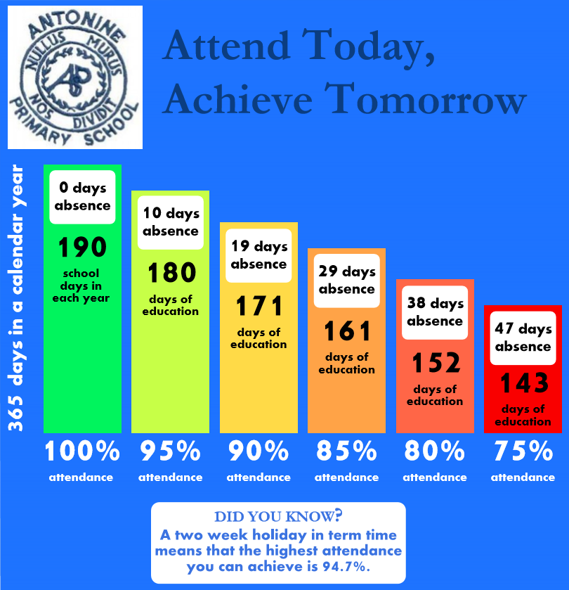

School Dress Code
Parents are asked to co-operate with the school in encouraging their child to follow the school’s dress code.

All schools have a dress code, which includes the school’s policy on uniform. The wearing of uniform is encouraged as it helps to:

- develop a school community spirit
- improves school security by making non-pupils more easily identifiable
- allows pupils to be easily identified when out of the school, e.g. on trips
- enhances the school’s reputation within the community; and
- minimises rivalry and bullying amongst pupils that can arise from, for example, the wearing of designer clothing.

The school’s dress code has been agreed in consultation with parents, pupils, staff and the Parent Council. This consultation has ensured that the dress code meets the needs of the school community, allows pupils to participate in all aspects of school life and is age appropriate.

The appropriate clothing and footwear for PE is a T-shirt, shorts and gym shoes with non-marking soles. These are necessary for health and safety reasons and your co-operation is requested to ensure that pupils are equipped to participate in the PE lessons.

Please ensure that all items of clothing are clearly labelled, particularly ties, sweatshirts and PE equipment, which are often lost. A protective apron or an old shirt should be worn for art and craft activities. Please help the school and the education authority by making sure that pupils do not bring valuable or expensive items of clothing to school.

In certain circumstances, appropriate clothing will be necessary for school activities for safety reasons, e.g. in games areas, science laboratories and technical workshops; this extends to the wearing of suitable footwear and even, on occasion, to the length of pupils’ hair and the wearing of jewellery and earrings.

Offensive clothing such as T-shirts or other items featuring inappropriate language or illustrations is not permitted. Football colours are also inappropriate as they can lead to incidents of rivalry.

If you have any queries regarding the school’s dress code, please contact the Headteacher.

Education Maintenance Allowance (EMA)
Information on Education Maintenance Allowance and how to apply can be found here: Benefits and support: Education Maintenance Allowance (EMA) - Falkirk Council

School Meals
Our Primary and Secondary menus offer a variety of healthy and appealing meal choices, fully compliant with the Scottish Government’s legal standards for food and drink in schools.

Primary School Menus feature three daily meal options; each served with two portions of vegetables and one portion of fruit. Secondary School Menus offer a wider selection, including plated meals, pasta dishes, meal deals, and salad boxes—each balanced meal includes two portions of vegetables and one portion of fruit.

Meal prices are reviewed annually. For up-to-date pricing and full menu details, please visit our website or contact your child’s school. (Schools: School meals - Falkirk Council)

All pupils in P1 to P5 are entitled to free school meals. Families with children in P6, P7, or secondary school may be eligible for free school meals depending on circumstances. For more information, please contact your child’s school or visit the Falkirk Council website.

Medically Prescribed Diets
If your child requires a medically prescribed diet, please request a Prescribed Diet Referral and Declaration Form from the School Office or download one from the website (Schools: School meals - Medically prescribed diets - Falkirk Council). This form must be completed and returned annually and must be supported by a diagnosis from a qualified medical professional.

All medically prescribed diets must be submitted through this process. Delay in returning the completed form may limit the meal options available for your child

Free School Meals & Clothing Grants
Information on Free School Meals & School Clothing Grant and how to apply can be found here: Benefits and support: Free School Meals and School Clothing Grants - Falkirk Council

School Holiday Support Payments
Information about School Holiday Support Payments can be found here: Benefits and support: Free School Meals: School Holiday Support Payments - Falkirk Council

Travel to and from School
Parents should remind their child(ren) that, in the interests of safety, good behaviour is expected from all pupils travelling on school transport.

Children should be reminded by parents that, wherever possible, they should only cross the road where there is a crossing patrol and should exercise care on walking to and from school.

Parents are requested, when dropping off/collecting children from school, that they do not park near the pedestrian exit or in any location which causes an obstruction and they take care not to restrict the view of the school crossing patrol.

Transport for Primary and Secondary School Children (Excluding Placing Requests)
Free school transport is provided to and from your home address to your child’s catchment school if they are distance entitled. Falkirk Council operate a more generous distance entitlement policy than required by law.

Distance entitled children are:

- All children under 8 years of age who live one mile or over from their catchment school by the nearest available safe walking route*.
- All children 8 years of age or over who live two miles or over from their catchment school by the nearest available safe walking route*.
*Note – a “safe walking route” assumes that the pupil is accompanied by a responsible adult.

Children who gain entry to any school by means of a successful placing request will not be entitled transport

Concessions, details of times of operation, criteria and application forms are available from the Transport Planning Unit within Falkirk Council. Tel: 01324 504724 / 504966.

Pickup points
Where home to school transport is provided, some pupils will require to walk a reasonable distance from home to the transport pick-up point but this should not exceed the authority’s agreed limit of 1 mile.

It is the parent's responsibility to make sure that their child arrives at the pickup point on time and behaves in a safe and acceptable manner while boarding, travelling in and leaving the vehicle. Children who misbehave can lose their right to home to school transport.

General Supervision
Before school begins supervision is very limited, therefore pupils should not arrive at school until as near to the school start time as possible.

During intervals school helpers supervise the children. In addition the Headteacher and Janitor are on call to cope with any difficulties which may arise. There is always access to the building and the children are made aware of this. For further information on these arrangements, please contact the school.

School Security
Falkirk Council aims to ensure the safety and security of pupils and staff when attending or working in a school. We use a number of security measures including a visitors’ book, badges and escorts, while visitors are within the school building. Anyone calling at a school for any reason, is required to report to the school office. The school staff then can make the necessary arrangements for the visit.

Wet Weather Arrangements
In wet weather pupils may be allowed into school during breaks and at lunchtime. However, as supervision during these periods is limited. It is especially important that school rules and expectations around behaviour are adhered to by all. Children having school lunches may remain in school during wet weather but, again, supervision is limited.

Parents Meetings
Our school offers opportunities for parents to discuss their child's progress with teachers, both formally and informally. Although arrangements vary from school to school, parents will be advised when these meetings take place. Over and above these set meetings, parents are welcome to contact the school at any time to ask for information or for an interview. Please see section two of this handbook for more details on home / school partnership.

Communication with Home
From time to time you will receive important and routine communications from the school. We are an ECO school and aim to be paperless. All communication is put onto the school app and emailed home. When necessary we will put a paper letter into school bags but this is very rare. Parents can advise us if email is not a suitable option and we will provide a paper copy.

Parents can contact the school by either phone or email. If nobody answers the answering machine will pick up your message. All emails should be sent to the generic school email and will be directed to the Headteacher in the first instance.

Unexpected Closures

Schools and nurseries can occasionally be affected by bad weather or building maintenance. If a school or nursery is closed, we will keep in touch using text messaging, show that it is affected here and detailed information about the closure will be available on the school's page. In the event of an early school closure please ensure that your child knows where to go if you are not usually at home during the day. To help us keep you informed it is important that you make sure we have the most up to date emergency contact information for your family..

Mobile Devices
Parents provide their children with mobile devices for a variety of reasons, including personal safety. It is the right of parents to allow their child to have a personal mobile device in school. However, if devices are brought to school there must be a clear understanding that the individual pupil is responsible for the care and usage of their device(s). Children are advised that they can access their phone before entering the playground in the morning and on leaving the playground at the end of the school day.

At all other times children are not permitted to use their phones within the school building and playground. This also includes at events such as discos, fayres, and other fundraising events. Pupils are not permitted to take photos within the school or grounds at any time.

Educational Psychology Service
The Educational Psychology Service is a statutory service with a role to provide advice to both the school and parents. Educational Psychologists work in collaboration with teachers, parents and other professionals to support children and young people with their learning and development, and to make the most of their lives.

Every school and pre-five establishment has a link Educational Psychologist who provides consultation, assessment, intervention, training and project work. The Service works within the Staged Intervention Approach of Children’s Services. We expect that all schools will have undertaken appropriate assessment and intervention at stage 2 before asking for educational psychology assistance.

The school must obtain the agreement of parents and, where appropriate, the pupil before involving the Educational Psychology Service. Further information is on the website https://blogs.glowscotland.org.uk/fa/epservice
As a statutory service we are required to publish a privacy notice which is available here: Privacy notices: Schools & education - Educational Psychology Service | Falkirk Council

Parents can contact the service directly on Educational Psychology Service educationalpsychologyservice@falkirk.gov.uk or 01324 506600. Please ask for the link psychologist for your child’s school or Nick Balchin, the Principal Educational Psychologist.

EPS Prioritisation
The Educational Psychology Service does not operate a waiting list system. We aim to be responsive as a service and so we do this through a prioritisation system.

A. Respond to statutory requests within agreed timescales these are written request for an educational Psychology Assessment from the parent, child/young person or the local authority from the Additional Support Needs Team

OR

B. Prioritise with school manager/cluster approximately termly and prioritise as follows:

- Critical incidents
- Children at risk of education placement breakdown
- Children where there is evidence that high levels of adaptation are required
- Assessment in relation to significant Additional Support Needs or placement change
- Exploratory Assessment to identify areas of concern

ICT Acceptable Use Policy
Falkirk Council Children’s Services recognises that access to Information and Communications Technology (ICT) equipment and services helps young people to learn and develop skills that will prepare them for work, life and citizenship in the 21st Century.

To support this, we provide resources for pupils and staff to use. The Children’s Services ICT Acceptable Use Policy (AUP) outlines the guidelines and behaviours that pupils are expected to follow when using school equipment or when using personally owned mobile devices in Falkirk Council establishments. The purpose of this is to protect young people online and to protect the Council’s network and equipment. The ICT Acceptable Use Policy (AUP) will be issued by the school for both parent(s) and pupil(s) to sign.

Equality
The Council is required to work towards eliminating unlawful discrimination, advancing equality of opportunity for all people and to foster good relations between people. The Council is committed to eliminating discrimination on the grounds of race, sex, disability, sexual orientation, religion/belief, age, marriage or civil partnership, transgender status, pregnancy/maternity, poverty or care-experienced background.

More information relating to our statutory obligations under the Equality Act 2010 can be found here: Equality and Human Rights - Falkirk Council
Education Services have a range of policies and procedures to address equalities issues specific to education to enable us to fulfil these duties. In addition to this all-education establishments have a responsibility to report incidents of prejudice-based bullying in line with our Anti-Bullying Policy: ‘Promoting Positive Relationships in Falkirk’s Educational Establishments’: Schools: School policies - Anti-Bullying Policy - Falkirk Council

English as an Additional Language (EAL Team, ASN Service)
As part of the Additional Support Needs Service, the Council provides a support service for children who have English as an additional language. The service supports enrolment and provides staff training and visits to schools to work with those children and young people who require assistance in developing English language skills.

This service can be contacted via email: EAL@falkirk.gov.uk

Religious Instruction and Observance

Religious Instruction

Religious and moral education in non-denominational schools and religious education in Roman Catholic schools is a statutory core subject for all pupils attending primary and secondary education, including those in years S5 and S6, and it is their entitlement to have this taught in a meaningful and progressive way. - Scottish Government Learning Directorate Curriculum for Excellence - religious and moral education

Schools have a statutory duty to provide Religious Instruction in the timetable. This aims to promote a knowledge of the Christian and other faiths and encourage children and young people to develop enquiring minds through investigating spiritual, moral and philosophical issues.

Religious Instruction may include visits to local places of worship, and/or visits from representatives of places of worship. This helps children and young people to develop knowledge and understanding of faiths, especially those with which they are less familiar.

Ultimately, pupils in the upper secondary school can gain a qualification through the study of Religious, Moral and Philosophical Studies at Higher and Advanced Higher Levels. These courses further develop young people’s skills in logical thinking, methodical enquiry and ways of expressing ideas effectively.

Religious Observance/Time for Reflection

Religious Observance, which may take the form of a Time for Reflection, is held at least six times a year, in addition to traditional celebrations central to the life of the school community. Religious Observance will often (but not necessarily) take the form of an assembly.

Withdrawal from Religious Instruction and Religious Observance/Time for Reflection

Parents who wish to exercise their right to withdraw their child from religious
observance are encouraged to discuss their intention with the Headteacher in the first instance to enable them to make a fully informed decision. Thereafter parents who wish to proceed to withdraw their child(ren) should notify the Headteacher in writing. This is so that alternative educational activities can be planned for their child(ren) during times of Religious Instruction and/or Observance.

Complaints
Information on how to make a complaint can be found via the following links:
Contact us: Complaints procedure - Falkirk Council
Schools: School complaints - Falkirk Council

School Health Service
NHS Forth valley has a statutory obligation to provide health services for all school age children. The aim is to make sure that all children and young people, throughout their school years, are in the best possible health to benefit from their education.

School Nursing Service
School Nurses are available 8.30am-4.30pm all year round, excluding Public Holidays. School Nurses are not based in schools and are part of an integrated community team working from local health centres/clinics. The School Nurse Team offer health screening, health assessments and health reviews.

A health review is offered to all children in primary 1. This involves a parent questionnaire and the opportunity of an appointment with the school nurse to discuss any parental concerns and a review of the child’s growth.
The Falkirk School Nursing team comprises of

- Registered School Nurses
- Health care support staff

Children/young people, parents/carers can request a health appointment at any time by contacting the service on 01324 679129.
Referral to the School Nursing Service can be made by Education, Social Work, GP, or other Health Care Professionals.

The Public Dental Service carries out dental inspections in Primary 1 and Primary 7 and can help access dental services for children not registered with a dentist.

Infectious diseases
Colds and tummy upsets are the most common infections affecting children at school. It is important to keep your child at home in the early stages of a cold or until at least 48 hours after an episode of diarrhoea/vomiting to prevent infecting others. For treatment of diseases such as chickenpox or mumps, please consult your GP practice or nurse.

Head Lice
Head lice are spread through head-to-head contact at home, whilst playing or in school. Regular wet combing of your child’s hair using a special comb is the best way to catch this problem early. Specific treatment lotions are available as shampoos are not effective. Two applications should be administered seven days apart. If this is not followed, re-infection is likely.
Further advice is available from leaflets about head lice which are available in all schools and health centres.

Clinics
Some children are asked to attend clinics (eye clinics, dentist, doctor etc) Please let the school know and arrange for your child to be collected if they must leave school to attend. No child will be allowed away from school without a responsible adult or unless written permission has been received from a parent or carer.

Primary Schools
Flu vaccines are given every year from Primary 1 onwards by an immunisation team visiting the school. Any child who misses a session can be vaccinated by their GP. Pupils with chronic illnesses such as asthma can visit their GP at any time to receive the vaccine.

Secondary Schools
Pupils are offered several vaccinations such as Meningitis ACWY, a catch-up for the MMR vaccine and a booster for diphtheria, polio and tetanus. From 2019 HPV vaccine will be offered to both boys and girls.

For more information: https://www.nhsinform.scot/

Medicines Administration
Administration of medicines prescribed by a doctor or dentist is at the discretion of the head teacher, but most schools are happy to co-operate. Parents who wish school staff to give medicines should take the medication to school and fill in the appropriate form (MED1). It is also possible to complete another form (MED4) which allows pupils to carry and administer medication themselves, for example inhalers. Prescribed medication should be clearly marked with your child’s name, date prescribed, how often it must be taken and for how long.

Pharmacies
Community pharmacies are trained in providing advice on coughs and colds, high temperature, fever, nasal congestion, minor eye infections, constipation, stomach upsets, fungal infections such as athlete’s foot, and skin problems such as impetigo.

Insurance Cover for School Children

Public Liability
Personal Injury
Falkirk Council has in place a Public Liability policy which operates in respect of claims for injury to any third party which includes a pupil whilst under the care of the Council or their employees. In order for liability to be accepted there is an onus to evidence the council was negligible in their acts and was responsible or partially responsible for the injury sustained

Pupil’s Property
It is inevitable that during each session, pupil’s property is lost, damaged or stolen from school. Parents are therefore discouraged from allowing their children to carry expensive items of personal belongings to the school and are reminded that a standard household policy can be extended to provide a degree of cover for personal items taken away from the home. Falkirk Council are not legally responsible for pupils property which is subsequently lost, damaged or stolen, unless specifically entrusted with a member of staff.

Any claim made for loss or damage to the property left in the care of the school or its employees will have to be submitted, in the first instance to Children’s Services. Following a thorough review of the claim, settlement will only be made if it can be shown that Falkirk Council are legally liable for the loss.

Travel and Personal Accident Cover – Educational Excursions
In order to provide necessary cover for educational excursions Falkirk Council has in place an insurance policy for travel and personal accident which specifically covers any pupil enrolled at a participating establishment. The policy provides compensation for each insured pupil should an incident occur, irrespective of legal liability. There are varying degrees of benefits within the policy, but the key compensation values are noted below.

1. Death £30,000
2. Permanent Total/Partial Disablement up to £30,000

The insurance policy provides accidental bodily injury cover whilst any insured person is undertaking an organised trip (including exchange visits and work experience placement) as long as it is with the authorisation of the school or council and the activities involve a journey outside the premises of the school. The policy also extends to cover overseas travel cover.

Section Two – Parental Involvement in the School

Parents welcome
All Falkirk Council schools welcome and encourage parental involvement and engagement. Research has shown that when parents are involved children do better in school.

Falkirk Council Education Services are in the process of reviewing our Parental Engagement Strategy in consultation with parents. This will be finalised ahead of the 2026-27 school year and will be uploaded here: Schools: School policies - Falkirk Council


Parentzone Scotland is a unique website for parents and carers in Scotland, from early years to beyond school. The website provides up-to-date information about learning in Scotland, and practical advice and ideas to support children’s learning at home in literacy, numeracy, health and wellbeing and science. Information is also available on Parentzone Scotland regarding additional support needs, how parents can get involved in their child’s school and education. Furthermore, the website has details about schools including performance data for school leavers from S4-S6; and links to the national, and local authority and school level data on the achievement of Curriculum for Excellence levels. Parentzone Scotland can be accessed at https://education.gov.scot/parentzone.

Parental Involvement and Engagement
We recognise that many of our parents have commitments during the day so we really value when they can become more actively involved in school life in one way or another.

Parents can help in school by doing practical activities, such as interacting with a small group during a reading, number or craft activity, by assisting in a trip by walking with a class to a local venue or helping supervise on a bus trip further afield. There are many activities teachers and early years officers have to do to prepare for lessons such as organising resources – parents could help with this and it needn’t take up too much time but would certainly facilitate learning.

Parents can also help by supporting a particular study the class is covering; they may have particular expertise they can share with the children, or they may be able to provide artefacts to help bring the topic to life.

All parents are members of the Parent Forum, with some getting further involved through the activities of the Parent Council and the Events Committee. Parents can also share good ideas to help to raise funds for the school- funds which are spent on pupil activities. Many of our parents and friends extend significant generosity by providing goods for sale at Christmas and Spring Fairs or by helping run a stall or the school café. Some parents with a PVG help run the school discos. The list is endless and if you have an idea about how you could help – get in touch!

Throughout the school year we ask our parents for their views on how we are performing. We hope for full engagement with these processes as they offer us good information about what parents feel they would like to happen in school. In addition, it affirms the ongoing work of the staff and others in the school community.
When parents meet with teachers’ valuable information is shared about how parents can help their child to learn. Parents are encouraged to engage in dialogue and share information which the teacher can use to develop learning for their child in school.

Parent Councils
Parents are welcomed to be:
- involved with their child’s education and learning;
- be active participants in the life of the school
- express their views on school education generally and work with the school.

All parents / carers are automatically members of the Parent Forum at this school. As a member of the Parent Forum all parents should –
- receive information about the school and its activities;
- hear about what partnership with parents means in our school;
- be invited to be involved in ways and times that suit you;
- identify issues you want the Parent Council to work on with the school;
- be asked your opinion by the Parent Council on issues relating to the school and the education it provides;
- work collaboratively with the school; and
- enjoy taking part in the life of the school in whatever way possible.

Parent Councils are the formal representative body for parents / carers with children attending school. Parent Councils are different in each school to enable them to meet the needs of parents / carers locally.
The Parent Forum decides how their representatives on the Parent Council are chosen and how the Parent Council operates. Parents / carers are encouraged to volunteer or put themselves forward to be chosen as representatives of the Parent Council if they wish.

The main aims of the Parent Council are:

- To support and work collaboratively with the school in its work with pupils
- To seek and represent the views of parents
- To promote contact between the school, parents, pupils, providers of nursery education and the community
- To report to the Parent Forum
- To be involved in the appointment of senior promoted staff in the school.
- To raise funds for the school for the benefit of pupils (in some schools the PTA/PA fulfils this role).
- To be included in School Improvement Planning

More information is available here: Schools: Parent Councils - Falkirk Council

For more information on parental involvement and engagement or to find out about parents as partners in their children’s learning, please contact the school or visit the Parentzone website at Parentzone Scotland | Education Scotland


Events Committee
The Events Committee is mainly responsible for arranging events for parents and raising funds for the school. Volunteers are welcome - please contact the school if you would like to join in. Meeting dates and times are shared in the school newsletter and on the school app.

Pupil Council
Two pupils from each class represent their peers and gather pupil views in school. In addition, the group will plan charity events and bring to the Head teacher views about various developments and fresh ideas on behalf of their classes. The group meets once every term to review the school improvement plan and evaluate learning.

Active Schools
The goal of Active Schools is to provide more high quality opportunities to participate in sport within schools. We also aim to ensure that these opportunities are well connected to and supported by other local, regional and national partners.

We work with Physical Education (PE) professionals to ensure better coordination between PE and school sports and also to encourage the development of more physically active children and young people.

While our focus is sport, our activities connect to the wider landscapes of play, dance, exercise and active living – we know that a joint effort is required to deliver the health and performance related fitness our children and young people deserve.

Within Falkirk Council we have an Active Schools Manager, nine Active Schools Coordinators (Primary) and nine Active Schools Coordinators (Secondary). The Coordinators work within their respective Primary and High Schools clusters to provide further opportunities for physical activity, sport and play. We also have a coordinator designated to disability sport.

Active Schools Falkirk | Falkirk Council (falkirkleisureandculture.org)
Follow us on @falkirksport

ECO Group
The school operates a very successful and effective ECO programme. In addition to the main pupil group there are ECO sub groups that meet throughout the school session. During these sessions they analyse effectiveness of the school as a whole and evaluate longer term projects, as well as making plans for future group, class or whole school activities. The school has gained ECO status on seven occasions. We have enjoyed ECO status since 2009.

Members of the ECO group also meet to plan activities that help our pupils stay safe out and about on the roads, including the daily journey to school. They engage with local Police to bring to the school good ideas to raise awareness for the need for personal safety.

School Ethos
The school values underpin everything we do.
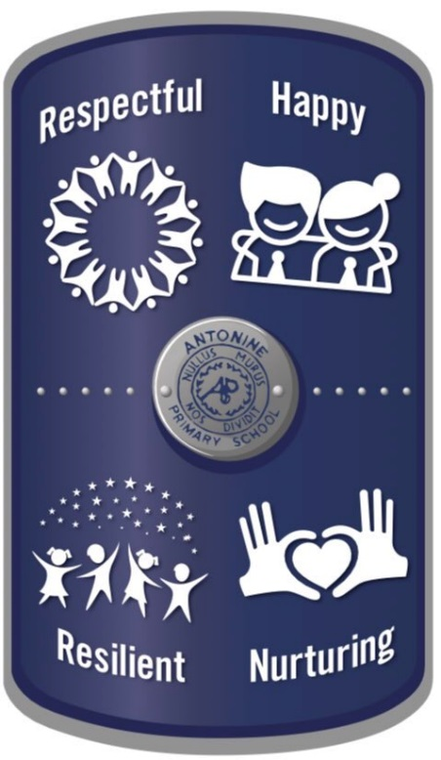

The school is proud of its pupils, past and present, and of their learning experiences and contribution to Antonine Primary School and Early Learning and Childcare Centre (ELC). Our school is relaxed enough to make everyone feel comfortable and welcomed - but it challenges pupils, as well as staff, to progress and develop in response to a fast-changing world.

We are delighted when our pupils achieve well in school and ELC, but we are also delighted when they achieve within their local and wider community. At our assemblies we issue certificates that promote our pupils becoming ‘Successful Learners’, ‘Confident Individuals’, ‘Responsible Citizens’ and ‘Effective Contributors’. We make contributions to local, national and global charities and have good fun as we raise money for others.

Pupils are encouraged to show respect for others as well as themselves. We deliver programmes that develop awareness of self-respect and of wellbeing. Health and well-being is an area we prioritise in school.

Our school Chaplain is from the church at Bonnybridge St Helen’s Church of Scotland. The minister will visit a number of times during the session to deliver assemblies. Although our school is non-denominational, i.e., not of one specific faith base, we encourage pupils to develop their spiritual awareness through a variety of classroom programmes and school assemblies.

Antonine Primary has a valuable and valued place in the local community. The school sits on the Antonine Wall and has the ‘motte’ of a medieval motte and bailey castle on its grounds. It sits on a site of historical interest and we promote this within our school programmes and through our school motto
‘Nullus murus nos dividit’ (No Wall Divides Us).

We enjoy links to local amenities such as Bonnyfield Park, Bonnybridge Community Centre, the local bowling green and nearby parks. We are close to many places of interest within the Falkirk Council boundary and ensure our pupils can access places to develop their learning.

Pupils engage with Eco, Fairtrade, Junior Road Safety, national sports events (e.g., Olympics, Commonwealth Games), local businesses and friends from the community who can develop skills and knowledge for learning, life and work. We make the most of activities offered through the Active Schools Programme which, throughout the school year, delivers after school clubs as well as other active learning experiences.

Rights Respecting Schools

Antonine Primary School has achieved Gold status
with Rights Respecting Schools. We are proud to place
an emphasis on pupil voice and informing our pupils of their rights. This approach underpins our Health & Well-Being focus. Pupils can join the Rights Respecting Ambassador Group to support the school’s work being done on informing pupils of their rights.

Development of pupil’s mental, social, and emotional wellbeing
The school is committed to supporting the development of the whole child and as a result, wishes to encourage their holistic wellbeing.

Mental, social and emotional wellbeing is supported in the following ways;

- Creating a school ethos which, in every way possible, gives value to these aspects of development, especially by providing an environment which is both caring and challenging and which provides opportunities for exercising rights and responsibility.
- Ensuring that staff and adults in the school act as positive role models for pupils.
- Providing opportunities for members of the school community to come together reinforcing shared values.
- Providing rich opportunities across all areas of the curriculum to develop mental, social and emotional wellbeing.
- Taking every opportunity within the curriculum and across the wider work of the school to celebrate diversity and promote equality.

A range of new local services, digital support and self-help information for school-aged children are available here: Falkirk Community Mental Health and Wellbeing (glowscotland.org.uk)

Pupil Conduct
A genuine partnership between the school and family is necessary to ensure the best possible standards of pupil conduct are shared, understood and underpin every interaction between children/young people, parents/carers and school staff.

Pupils are expected to set themselves high standards in appearance and behaviour. School rules are devised to encourage the maximum amount of self-discipline. The rules make clear what is expected of pupils, and how they are required to behave. The general aim is to produce an atmosphere of friendly co-operation, encouraging respect and consideration for other persons and for property. A behavioural agreement is included in the School Enrolment Form that parents complete when enrolling their child(ren).

Restorative Approach to Bullying Behaviour
Whilst many believe that children who display bullying behaviour should be punished, it is widely accepted that this type of response can at times be ineffective, and make the situation worse.

The adoption of restorative approaches is evidenced to be a more effective response than traditional methods. Pupils are given the opportunity to accept responsibility for their actions, recognise the harm done and are supported to find restorative responses to the harm they have caused.
There are times where sanctions are appropriate; exclusion is seen as a last resort and carried out when incidents fall within the legislative criteria.

Falkirk Council has a responsibility to provide an education for all pupils and to challenge and address bullying behaviour. Whilst appropriate action will be taken by the school, it is also important that all parent/carers, work with the school to resolve any issues in the best interests of their child or young person.

Parents can access Falkirk Council’s Anti-Bullying Policy, ‘Promoting Positive Relationships in Falkirk’s Educational Establishments; on the Council website: www.falkirk.gov.uk/services/schools-education/policies-strategies/anti-bullying-policy.aspx

Antonine Primary School has a nurturing environment that promotes positive behaviour and has programmes in place to support this. Each teacher creates with the class an agreed “Class Charter” whereby the class can function well to allow all pupils to learn. School staff work together to gain an understanding of the needs of individual children so that those who struggle with any kind of learning issues can have the best support possible. There is a culture of mutual respect where differences are valued. School staff are trained in restorative approaches to conflict.

Pupil motivation is high – different learning styles are adhered to, parents are very involved in learning through homework links and communication, success both within and out-with school is celebrated, and Personal and Social development programmes are in place in classes and through engagement in assemblies.

Pupils take part in activities run by Falkirk Council’s creative learning and sports teams allowing pupils to travel to different venues and experience learning in a different environment.
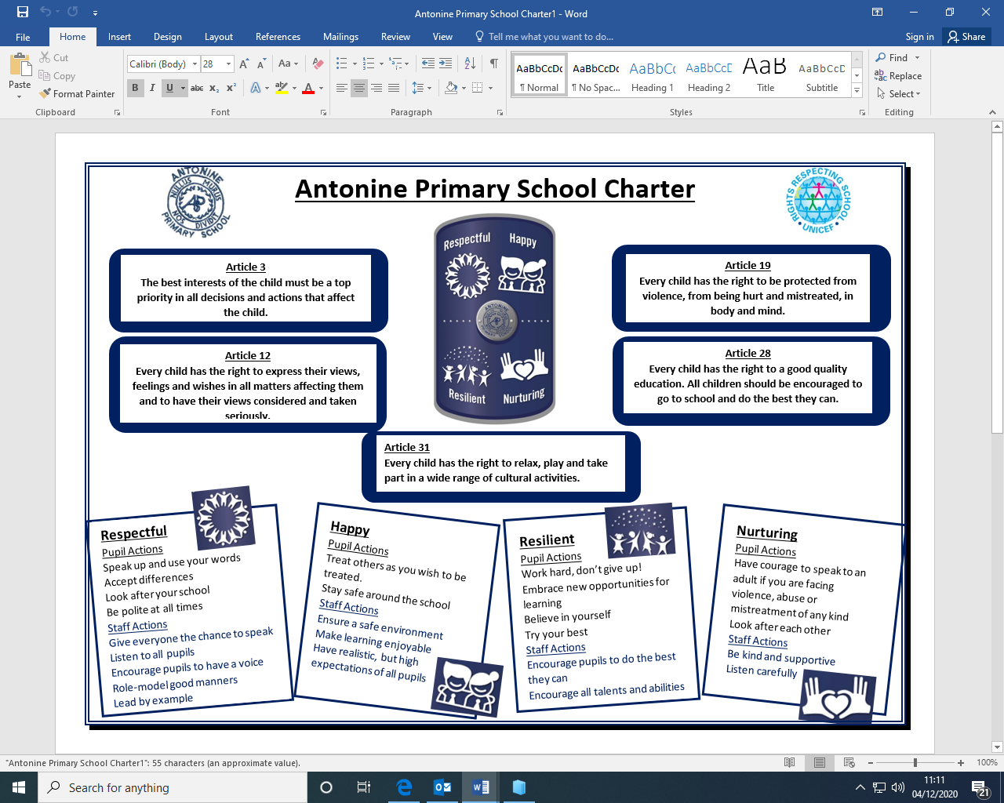

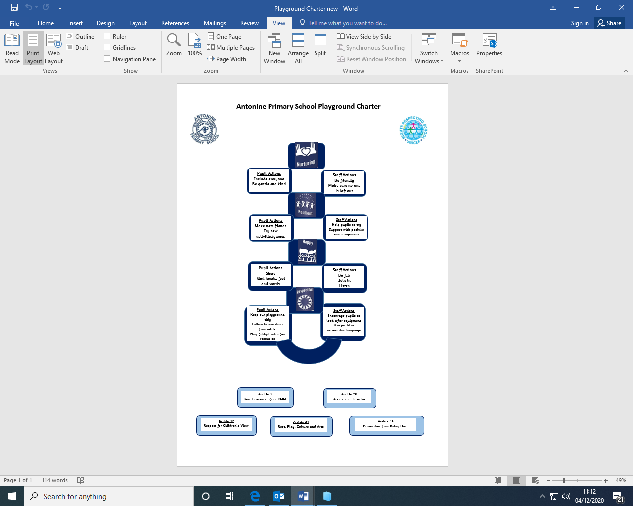

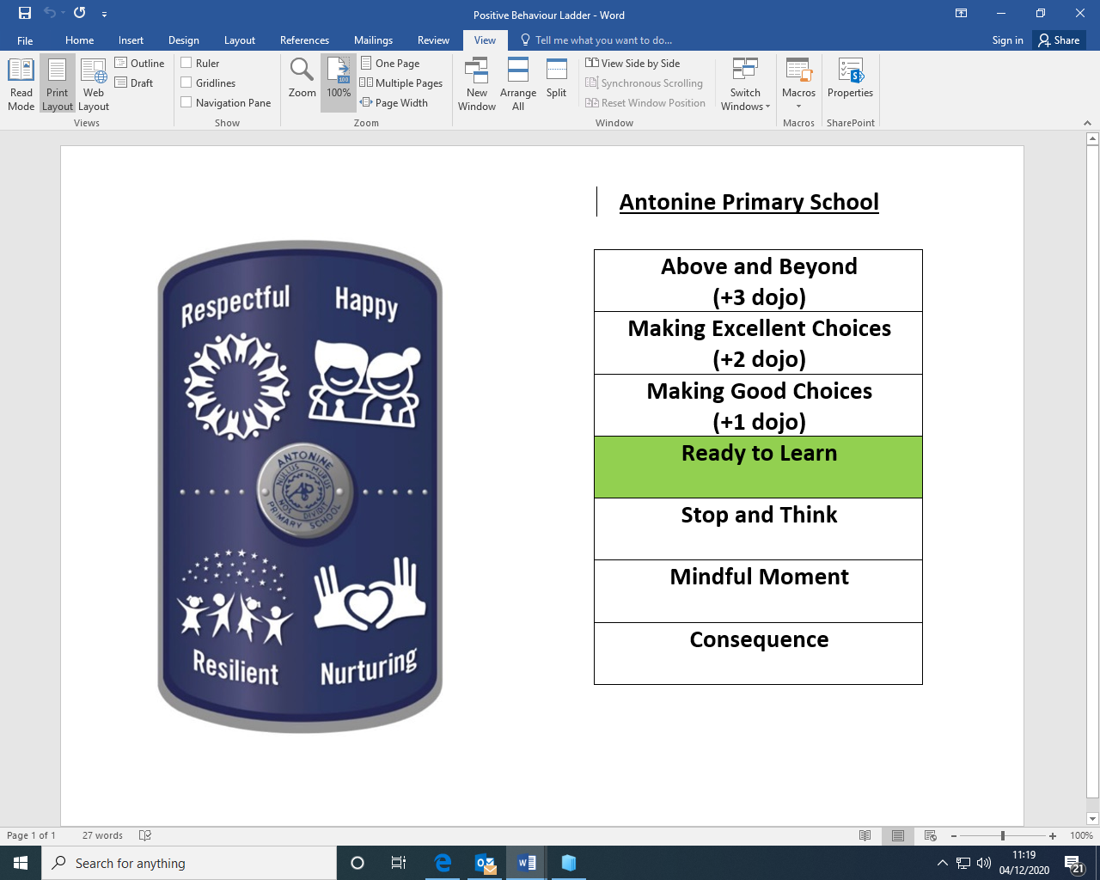

This is our positive behaviour ladder – it supports pupils to make the best choices whilst in school and rewards positive behaviour.

Pupils are encouraged through curriculum programmes to develop a healthy lifestyle, including personal wellbeing, developing the ability to make good choices, personal fitness and healthy eating.
Please access the school’s Standards and Quality report in the school website to read some comments made by pupils, parents and staff:

http://antonineps.schoolwebsite.scot/

Standards and Quality Report
Every year each school publishes a Standards and Quality report which highlights the school’s major achievements.

Standards and Quality Reports – Operational Guidance

Schools and centres must provide an annual Standards and Quality Report (SQR) as a record of the progress made with the annual improvement plan. The SQR should be based on the results of on-going self-evaluation which is rigorous, effective and based on consideration of impact. This self-evaluation should be informed by How good is our school? 4th edition (HGIOS?4) and/or How good is our early learning and childcare? (HGIOELC?) and How good is OUR school? It should give a clear indication of where the school is now in relation to its process of continuous improvement.

It should state clearly and briefly the progress towards the National Improvement Framework (NIF) priorities and drivers and Children's Services NIF Improvement Plan priorities. The report should be written using evaluative language.

The National Improvement Framework’s key priorities are:

- Placing the human rights and needs of every child and young person at the centre of education
- Improvement in children and young people’s health and wellbeing
- Closing the attainment gap between the most and least disadvantaged children and young people
- Improvement in skills and sustained, positive school-leaver destinations for all young people
- Improvement in achievement, particularly in literacy and numeracy.

The drivers of improvement identified in the NIF are:

- School and ELC leadership
- Teacher and practitioner professionalism
- Parent/carer engagement and family learning
- Curriculum and assessment
- School and ELC improvement
- Performance information

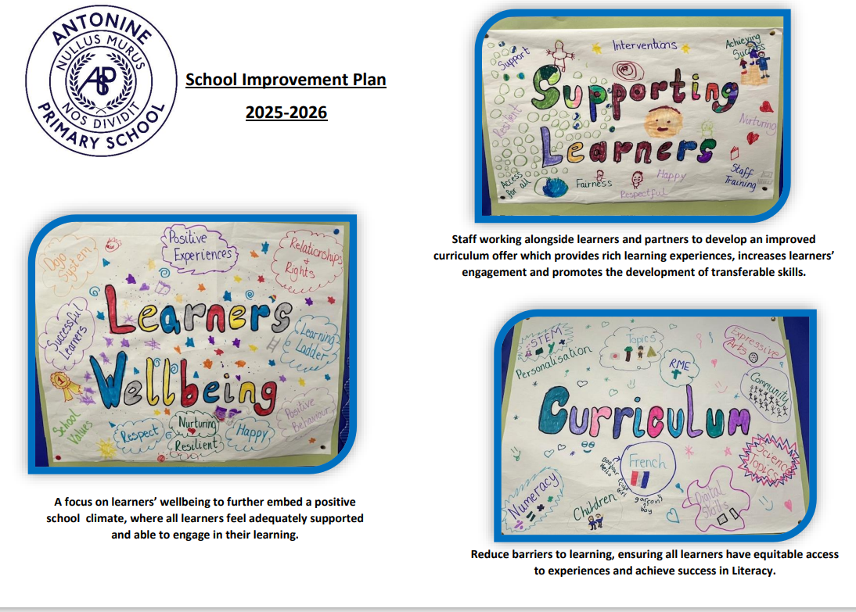

Section Three – School Curriculum

Curriculum for Excellence
Bringing learning to life and life to learning

Curriculum for Excellence has now been introduced across Scotland for all 3-18 year olds – wherever they learn. It aims to raise standards; prepare our children for a future they do not yet know and equip them for jobs of tomorrow in a fast-changing world.
Glow, Scotland’s unique, world leading, online network supports learners and teachers and plans are already in place for parents across the country to have access to Glow. Parents should ask the school how to arrange access to Glow and a user name and password will be issued.

Teachers and practitioners will share information to plan a child’s ‘learning journey’ from 3-18, helping their progression from nursery to primary, primary to secondary and beyond, ensuring each transition is smooth. They’ll ensure children continue to work at a pace they can cope with and with challenge they can thrive on.

Curriculum for Excellence balances the importance of knowledge and skills.
Every child is entitled to a broad and deep general education, whatever their level and ability. Every single teacher and practitioner will be responsible for the development of literacy and numeracy and health and wellbeing from Early Level through to Senior Phase.

It develops skills for learning, life and work, bringing real life into the classroom, making learning relevant and helping young people apply lessons to their life beyond the classroom. It links knowledge in one subject area to another helping make connections in their learning. It develops skills which can enable children to think for themselves, make sound judgements, challenge, enquire and find solutions.

There are a variety of ways assessing progress and ensuring children and young people achieve their potential. This includes teachers’ professional judgement, Scottish National Assessment and national qualifications.

There is an entitlement to personal support to help young people fulfil their potential and make the most of their opportunities with additional support wherever that’s needed. There is an emphasis by all staff on looking after our children’s health and wellbeing – to ensure that the school is a place where children feel safe and secure.

Ultimately, Curriculum for Excellence aims to improve our children’s life chances, to nurture successful learners, confident individuals, effective contributors, and responsible citizens, building on Scotland’s reputation for great education.

At Antonine Primary we help our children to develop skills for learning, life and work, including literacy, numeracy and health and wellbeing in and out of the classroom.

- Learning to Achieve - Our core educational policy.

This describes in detail how Curriculum for Excellence will be delivered in our educational establishments. We use Learning to Achieve along with the national guidance to monitor, develop and improve outcomes for children and young people.

- Curriculum for Excellence – Bringing learning to life and life to learning.

Curriculum for Excellence is the vehicle by which we deliver a Quality Education across the 4 Contexts of Learning. It aims to raise standards; prepare our children for a future they do not yet know and equip them for jobs of tomorrow in a fast-changing world.
Curriculum for Excellence balances the importance of knowledge and skills. Every child is entitled to a broad and deep general education, whatever their level and ability. It develops skills for learning, life and work, bringing real life into the classroom, making learning relevant and helping young people apply lessons to their life beyond the classroom. It links knowledge in one subject area to another helping make connections in their learning. It develops skills which can enable children to think for themselves, make sound judgements, challenge, enquire and find solutions.

- Responsibility of all

Every single teacher and practitioner will be responsible for the development of literacy and numeracy and health & well-being from Early Level through to Senior Phase.

Teachers and practitioners will share information to plan a child’s learning journey from 3-18, helping their progression from nursery to primary, primary to secondary and beyond, ensuring each transition is smooth. They’ll ensure children continue to work at a pace they can cope with and with challenge they can thrive on.

There is an entitlement to personal support to help young people fulfil their potential and make the most of their opportunities with additional support wherever that’s needed. There is an emphasis by all staff on looking after our children’s health and well-being; to ensure that the school is a place where children feel safe and secure.
GLOW, Scotland’s unique, world leading, online network supports learners and teachers. Learners have individual access to GLOW through a username and password issued by school.

Developing the Young Workforce
Collaborative working between early years, primary and secondary alongside partnership working with local employers and businesses enhances your child’s experiences from Early Years to their point of exit from school. Curriculum planning and structures in schools have continued to evolve progressively as new qualifications have been introduced. There is now a wide range of opportunities for young people to develop their employability skills, gain experiences of the world of work and incorporate work-based learning elements together with employers to explore direct pathways into employment. Each Secondary school has a DYW School Coordinator, who are all committed to strengthening links with employers and to create a genuine partnership approach to employability opportunities for all learners.

For more information please see the following websites:
DYW - Scotland - DYW Scotland - Home
Forth Valley - DYW - Scotland

Assessment and Reporting
There are a variety of ways to assess progress and ensure that children and young people achieve their potential. Effective assessment practice within schools and establishments include:
- Learner involvement in setting personal targets and next steps
- On-going self-evaluation by learners, staff and school leaders
- Identification of strengths and next steps
- A range of approaches to assessment
- A variety of evidence gathered informally on a day-to-day basis or formally at certain points throughout the year (not exclusively - Teachers’ professional judgement, Scottish National Standardised Assessments, National Qualifications)
- Moderation of standards using Education Scotland Experiences and Outcomes and Benchmarks
- Consideration of data analysis and performance information

Achievement of a Level & Scottish National Standardised Assessments (SNSA):
Learner’s progress is defined within the following levels:
Level | Stage
Early | Pre-school and P1 however may be later for some
First | To the end of P4 however may be earlier or later for some
Second | To the end of P7 however may be earlier or later for some
Third & Fourth | S1 – S3 however this may be earlier for some
Senior Phase | S4-S6 and college or other means of study

Achievement of a level means that the learner has achieved a breadth of learning across the curriculum area and has met the appropriate benchmarks; that they have responded consistently well to the level of challenge in their learning and can apply what they have learned in new and unfamiliar situation.
From August 2017, National standardised assessments have been introduced to all schools across Scotland in aspects of reading, writing and numeracy, for all learners in P1, P4, P7 and S3.
These assessments sit alongside a wide range of other evidence including ongoing classroom assessment of all aspects of literacy and numeracy. They cannot be used alone to confirm judgements of achievement of a level.

- Within schools and establishments, finding out about your child’s progress includes:

  - Attending parents’ information evenings
  - Discussing progress with teacher staff and school leaders by appointment
  - Attend open evenings/afternoons including “meet the teacher” events
  - Reading learning logs or diaries (which usually invite parents/carers to comment)
  - Progress Reports (sent home to parents/carers including an invite to make comments)
  - Tracking and Monitoring Reports (regular attainment data provided to track progress)
  - Social media updates from staff and/or the school
Further information about what data is collected about your child is given in section 5 of this handbook.

Extra Curricular Activities
Every school is encouraged to offer as wide a range of sporting and cultural activities as possible. In this context, the Authority provides a degree of financial and administrative support for leagues, competitions, festivals and similar events but it is recognised that, again, the help of parents and the community is irreplaceable. Quite separately, the Council and other partner organisations also undertake to organise and administer certain events and many schools take part in these.

There is a range of extra curricular activities available for pupils during lunchtime and after school. Parents will be informed about these by the school. In addition to in-school activities, classes also make regular educational visits and field studies. Wherever possible, these visits are linked to pupils’ class work.

Where participation involves children travelling or staying late after school, written permission for children taking part is required from parents

Play Pedagogy and Active Learning
Curriculum for Excellence emphasises the value of an active learning approach. Active learning is engagement of the brain whilst participating in learning experiences.

In the early years, children will have a range of learning experiences that include planned and purposeful play and stimulating learning which engages and challenges children’s thinking using real life and imaginary situations.

As children progress through school, they continue to be involved in active learning experiences which give them ownership of their own learning, encourage co-operative working, and utilise skills required for learning, life and work.

Planning Children’s and Young People’s Learning
Practitioners use a variety of approaches to ensure that pupils understand the purpose of their learning and are clear about how to be successful. A variety of planning approaches are used to ensure that experiences are progressive, skills – focused and meet pupils’ learning needs. Often individualised targets help pupils to assess their own learning.

Learning at Home
Schools should add specific arrangements about other home learning approaches which may be in place – particularly around digital learning.

Practitioners provide home learning activities to support reinforcement of learning or to encourage pupils to apply learning in different ways, often in real life situations.

Parents are encouraged to get involved in home learning tasks. This helps parents keep up-to-date about learning in class and promote positive learning partnerships.

Care of Books / Materials
To enable us to provide the best possible education for your child, every care should be taken to look after the school’s resources and facilities. Parents are asked to remind their child(ren) that all school equipment and fitments should be used with care. Books and learning resources which are lost or destroyed must be paid for, either wholly or in part, depending on the age of the resource. Any loss of school or Council property should be reported immediately to the school.

Sensitive Aspects of Learning
Parents will be informed about sensitive aspects of learning being taught e.g., relationships, sexual health, parenthood, drugs awareness etc. before classes begin this important work. This will allow parents to prepare their children or to support them further at home.

After School Activities
Every school is encouraged to offer as wide a range of sporting and cultural activities as possible. In this context, the Authority provides a degree of financial and administrative support for leagues, competitions, festivals, and similar events but it is recognised that, again, the help of parents and the community is irreplaceable. Quite separately, the Council and / or Falkirk Community Trust and other partner organisations also undertake to organise and administer certain events and many schools take part in these.

There is a range of extra-curricular activities available for pupils during lunchtime and after school. Parents will be informed about these by the school. In addition to in-school activities, classes also make regular educational visits and field studies. Wherever possible, these visits are linked to pupils’ class work.

Where participation involves children travelling or staying late after school, written permission for children taking part is required from parents.

There are some extra-curricular activities available for pupils during lunchtime and after school. Parents will be informed about these by the school. Denny High School runs some evening and after school clubs through Active Schools – information can be shared via Denny High or on ‘Active Schools’ number below. In addition to in- school activities, classes also make regular educational visits and field studies, usually linked to pupils’ class work.

Facilities for Physical Education and Outdoor Activities
The gym hall has a variety of apparatus for physical education within the school. As part of the school’s physical education programme, pupils may also use the facilities of the local sports complex, swimming pool or athletics stadium or other relevant venues, including the school grounds. All Scottish pupils are entitled to two hours of PE per week.

Section Four – Support for Pupils

Getting It Right For Every Child (GIRFEC)
Getting it Right for Every Child (GIRFEC) is underpinned by the United Nations Convention on the Rights of the Child (UNCRC). The UNCRC was produced in 1989 and contains 54 Articles specifically for children, recognising the special care and protection they need throughout childhood to experience the full range of human rights: civil, cultural, economic, political, and social rights.
The Scottish Government is committed to recognising, respecting, and promoting children’s rights as part of its wider commitment to improving life chances for all children and young people. The UNCRC lies at the heart of the Scottish Government’s policy and practice.

UNCRC: the foundation of Getting it right for every child - gov.scot (www.gov.scot)

Getting it Right for Every Child (GIRFEC) is the Scottish Government’s approach to improving children’s services. The wellbeing of all children and young people is at the heart of GIRFEC. Services must work together with children, young people, their families, and those responsible for their care, to provide quick and effective support. To support the GIRFEC approach, the Children and Young People (Scotland) Act 2014 ensure key parts of GIRFEC are within law.

Wellbeing
The GIRFEC approach looks at eight areas of wellbeing. These are recognised as required areas which children and young people need to flourish both now and in the future.
The eight wellbeing indicators are:

- Safe | - Active
- Healthy | - Responsible
- Achieving | - Respected
- Nurtured | - Included

These enable the adults responsible for the care and wellbeing of children and young people to provide them with support. These areas help children and young people, families, those responsible for their care, and services, to identify any needs. Through a collaborative approach children and young people, families, those responsible for their care, and services will use these eight wellbeing indicators to identify any need and respond with appropriate planned solutions and supports.
This approach provides a common language and areas to focus on when gathering information about a child and young person’s world, to ensure they are growing and developing (UNCRC Article 6).
Policies & strategies - Getting it Right for Every Child (GIRFEC) | Falkirk Council

Main Contact
In 2019, the Scottish Government repealed the relevant sections of the Children and Young People (Scotland) Act 2014 relating to the Named Person service. A named person was defined as a central point of contact for children, young people, and parents. This person had the responsibility for providing families with information for getting the support if, and when, they needed it. As a result of the Scottish Government’s decision, education authorities are no longer legally required to provide this service.

Every child and young person will still have a main contact within a school establishment to support and promote their wellbeing. The role of the main contact is to act as the first point of contact for children, young people, those responsible for their care, and families.

If the main contact is not available, please speak to another member of staff who will be able to help. During school holidays an officer from Children’s Services Central Team will provide the advice and support you may require.

Family Support Services

Family Support Services work in partnership with families, schools, and other agencies to support young people’s wellbeing from early intervention to more intensive support.
Children, young people, and families may require additional support at different times in their life due to changing circumstances, such as: following a bereavement, trauma, illness, increased anxiety, and transition points in life. Support can be tailored to meet the individual needs of children, young people, and families, when they need it most and as locally as possible.

A request for support can be made through a member of school staff (main school contact) who will be able to talk with you, gather information and your family’s views. This helps identify the most appropriate service. Support can be delivered in school, at home or in the community, on an individual or group basis.

Protecting Children and Young People

Article 19 of the UNCRC states that all children and young people have a right to be protected from violence, abuse and neglect. Everyone who works with children or young people has an important role in keeping them safe. Any individual could identify a concern that a child or young person may be at risk from abuse, neglect, exploitation or violence.

Falkirk Council has clear procedures for all staff to follow when there are concerns that a child might have been abused, are at risk of abuse or are likely to be exposed to significant harm. Sharing relevant information is an essential part of protecting children. Where there is concern about a child’s safety or welfare, relevant information will be shared with police or Social work without delay, provided it is necessary, proportionate and lawful to do so.
All concerns that may indicate a risk of significant harm will lead to an Inter -agency referral discussion (IRD). This multi-agency forum involving Social Work, Police, Health and Education share relevant information they hold about the family and will decide on the next steps that are required, whether to progress an investigation and make plans to ensure the immediate safety of the child.

Additional Support Needs
As with all local authority schools in Scotland, this school operates under the terms of the Education (Additional Support for Learning) (Scotland) Act 2004 (amended 2009) and its accompanying Code of Practice. This has been strengthened through the Children and Young People (Scotland) Act 2014.
Further details of the policies and procedures can be found on the Falkirk Council website:
Additional Support Needs - Falkirk Council
Children, young people, and families will work together with this school, other agencies and professionals to provide the best possible educational provision to meet their needs within the resources available. This may include working with Social Work Services, Educational Psychology Service, and the National Health Service.

Support for Pupils
The school makes provision for pupils with additional support needs throughout their education (UNCRC Articles 23, 28 and 29):
- each teacher differentiates the Curriculum for Excellence within their class to provide educational targets and objectives suited to their age and stage of development
- the school has an experienced Support for Learning Teacher or Pupil Support Teacher to co-ordinate and organise support for children
- the school can utilise Support for Learning Assistant time for exceptional cases

For the children and young people who require further support, the GIRFEC wellbeing indicators, and other assessments, may be used to identify their additional support needs. Those involved in helping to complete a rounded picture of assessment are referred to as the Team Around the Child (TAC) (UNCRC Article 3).
Members of the TAC may include the following. Depending on the circumstances, others may be involved:
- the child or young person (UNCRC Article 12)
- parents or carers
- others responsible for the care of the child or young person
- school staff
- social work
- Children’s Rights Officer
- ASN Advisor

The Team will also draw up and review plans to meet the identified needs. Their activities are co-ordinated by the Lead Professional, who is responsible for ensuring plans are implemented and has an overall picture of the child or young person’s progress.
If you believe your child may have unrecognised additional support needs, your first point of contact should be the child’s class teacher (primary) or their Guidance teacher/Pastoral Head (secondary).

Disputes and Resolution (Additional Support Needs)
Schools and Early Learning Centres (ELC) do their best to support and respond to the needs of their children and young people. It is important for good communication between home and school so that should a problem arise, it can be identified and discussed as soon as possible.
In the first instance, the school or ELC should be contacted directly. If the matter cannot be satisfactorily resolved, services from centrally based staff may be called upon: the Additional Support for Learning Adviser, the Educational Psychologist or the school’s attached Team Manager. Children’s Services also commission independent mediation through Children in Scotland. This is a free service to parents, carers, and young people. It offers an independent mediation service by fully trained, experienced mediators in neutral venues and operates with a child- centred approach. Their services, called Resolve, may be arranged by the Additional Support for Learning Adviser, or accessed directly by parents and carers.
Parents, carers and children or young people with additional support needs can also seek independent advice and support through:
- Enquire – the Scottish advice and information Service for additional support for learning managed by Children in Scotland: www.enquire.org.uk, info@enquire.org.uk 0345 123 2303
- Resolve: ASL - to contact the service, or to find out more: www.childreninscotland.org.uk, info@childreninscotland.org.uk Sandra Mitchell, Mediation Manager smitchell@childreninscotland.org.uk Children in Scotland, Thorn House, 5 Rose Street, Edinburgh EH2 2PR
- Scottish Independent Advocacy Alliance - www.siaa.org.uk, enquiry@siaa.org.uk 0131 510 9410
- Let’s Talk ASN Scotland - is a Scottish Government funded service for the parents of children with additional support needs and run in partnership with Barnardo’s. The service provides legal representation in appropriate education law cases to parents or pupils. It also provides advocacy support for families with a right of reference to the ASN Tribunal for Scotland., c/o Govan Law Centre, letstalkasn@edlaw-org.uk 0141 445 1955
- Children and Young People’s Commissioner Scotland - www.cypcs.org.uk/about/

More detailed information about Falkirk Council’s ASN service can be found here:
Falkirk Council Additional Support Needs | Supporting Children & Young People with Additional Support Needs Across Falkirk Council (glowscotland.org.uk)

Educational Psychology Service
Educational Psychologists work in collaboration with teachers, parents and other professionals to support children and young people with their learning and general development, and to make the most of their lives, particularly in educational settings.

Every school and pre-five establishment has a link Educational Psychologist who provides consultation, assessment intervention, training and project work. We work within the Staged Intervention Approach of Children’s Services

The school must obtain the agreement of parents and, where appropriate, the pupil before involving the Educational Psychology Service. Further information is on the website https://blogs.glowscotland.org.uk/fa/epservice.

Transitions
The ELC (Early Learning and Childcare Centre), although having its own secure entrance, is connected to the main school building and has two-way access into the school. Children from the ELC and the school therefore use many opportunities to access each other’s learning spaces. School age children of various ages visit the nursery to share learning experiences or to act as ‘buddies’ to the younger children. In addition, the school accommodation and grounds are used by all – the nursery children particularly enjoy their visits to the ‘fairy garden’ which is an outdoor classroom.

Primary 1 pupils create a package of information for the new intake which may include a film of a ‘normal’ day in P1, including footage of how to manage daily routines, for example, lunchtimes.

Transitions from stage to stage in the school are managed by class teachers who share information well before the time is due to move on to the next stage.

Denny High School and the Denny cluster Primary Schools operate together a rich series of transition events. By the time the Primary 7 pupils are ready to start High School in August they are very familiar with routines and expectations. They will have made a number of visits to familiarise them with the new format of timetabling of their day, they will have experienced different subject areas, and they will also have met many of their peers from the various cluster primaries through curricular events.

In the midst of all these changes we ask that parents/ carers maintain a good communication link with us to keep us informed of anything that will help a transition be as smooth as possible. We ask that you give your child opportunities to talk about the changes and that you allow them to access the correct uniforms and resources that will help them move forward in confidence.

Nursery Class Provision
The school’s nursery class provides places for children aged 3-5 years.
Nursery class provision is non-denominational, which allows children of parents from all religions and beliefs to attend the nursery. Attendance at the nursery class does not however guarantee a place in the school.

Admission to Early Learning & Childcare (ELC) Establishments in Falkirk
ELC places are allocated according to the Early Learning and Childcare Admission Policy. A funded pre-school education place is available for every child aged 3 to 5 years who lives in Falkirk. A funded place can be provided in either a Falkirk Council ELC Centre, private nursery or childminder which is in partnership with Falkirk Council.

Children become eligible for pre-school education as follows:
- For children who reach 3 years of age between 1st March and 31st July the start date will be the beginning of the Autumn Term (August)
- For children reaching 3 years of age between 1st August and 29th February of the following year the start date will be a month after the child’s 3rd birthday.

Parents can apply for a nursery place between 1st December to 28th February each year via the Council’s website Early learning and childcare: Funded early learning and childcare - Falkirk Council

Please note you will need to create a MyFalkirk account before applying.

Transition from Nursery to Primary
Each establishment has a detailed approach to ensure a smooth transition for children to primary school. This involves nursery and primary staff working together to share information about children’s progress and achievements which will inform future planning.

Primary School Admissions
Education Services must set a date each year for the commencement of children’s attendance at Primary school. This date is usually the 3rd or 4th week in August.

When commencing Primary 1 education, your child will normally attend the local denominational or non-denominational Primary school and transfer from it, after Primary 7, to its associated Secondary school. Details of the catchment areas and boundaries can be obtained from the Forward Planning Section – Tel. 01324 506608 in Education Services, on the website - www.falkirk.gov.uk or the relevant school.

Pupils who are baptised Roman Catholic and who live within the catchment area of a denominational school are automatically entitled to enrol at the school. All other pupils will require a placing request (see below).

Primary 1 enrolments will be accepted from 1st November until 31st December each year. Parents will receive information regarding the enrolment arrangements via Groupcall in October. Adverts will also be placed in the local press and all nurseries and schools.

Parents of pupils enrolling at a denominational school must also present their child’s RC baptismal certificate. Parents of pupils that are not RC baptised will be required to submit a placing request (see below).
You are still required to enrol your child(ren) at your catchment denominational school (if RC baptised) or catchment non-denominational school (if not RC baptised) even if you do not wish him/her to attend that school.

Information on enrolments will also be available through the Falkirk Council website at www.falkirk.gov.uk.

Children eligible for enrolment are those whose 5th birthday falls between 1st March and the end of February the following year. Requests for enrolment will only be prioritised if Education Services receive more requests for enrolment than places available at the school.

Primary to Secondary Transfer
There are a range of activities that take place to ensure that all children are well supported as they move from Primary 7 to 1st year, and these are all decided by each secondary school and its associated primary schools.

Generally, visits take place in the summer term, with a programme of activities for pupils in classroom relating to their secondary subjects. Sporting and social activities may also be planned. Pupils, therefore, become familiar with the new school, their new teachers, and their new classmates.

Clusters also arrange for secondary school subject teachers to visit Primary 7 classes from time to time, with the cluster agreeing each year which subject areas should be the focus for these. Opportunities for senior pupils from secondary schools to visit classes in their associated primaries offer further reassurance and can help supportive peer relationships to be developed before S1 begins.

Most secondary schools also have an information evening for parents of Primary 7 children at which they can gain information about uniform, lunchtime arrangements, school clubs, etc.

Pupils with Additional Support Needs
Secondary school Pastoral and Support for Learning teachers make visits to the Primary 7 class to get to know the children and their needs, including any Additional Support for Learning needs. Visits by Support for Learning staff sometimes take place as early as Primary 6 to help with additional arrangements for those children for whom the move to secondary school may present challenges.

Moving to the denominational secondary school
Children who are baptised Catholic
With the exception of some pupils at St Patrick’s PS, pupils who are in Primary 7 in denominational primary schools (Sacred Heart PS, St Andrew’s PS, St Mary’s PS, St Francis Xavier’s PS and St Joseph’s PS) move to St Mungo’s HS.
Pupils in Primary 7 at St Patrick’s PS attend St Modan’s HS in Stirling.

Children who are non-Catholic
Parents of non-RC baptised pupils who were enrolled through a Placing Request at a denominational primary school must submit a further Placing Request if they wish them to transfer to St Mungo’s High School. These pupils are, otherwise, automatically entitled to transfer to their catchment non-denomination secondary school.

Moving between denominational and non-denominational schools
Parents who intend to send their children to St Mungo’s HS from a non-denominational primary school, or from a Catholic primary school to their catchment non-denominational high school, should make known their intentions both to the primary school and the secondary school as soon as possible. This enables the necessary transfer arrangements to be made. A placing request will also be required.

Mid Session Transfers
You may make a Placing Request at any time during a school session. If your child is experiencing problems at school, you are advised to discuss the matter with the Head Teacher prior to making a Placing Request. Completing the Application Form does not guarantee a place for your child at your chosen school.

Transport for Placing Requests
If a Placing Request is successful, parents will be responsible for the safety and transportation costs of their child to and from their chosen school.

Section Five – School Improvement

Raising Attainment
Assessment is an integral part of the teaching process and your child will be continually assessed during their school career. This assessment can be both formal and informal and takes many forms; observation, tests, pupil/teacher dialogue, written or spoken tasks and teacher judgement. The result of the assessment process allows teachers to form next steps in your child’s learning.

Monitoring performance and using the resulting information to secure improvement is an important part of the work of head teachers, school staff and officers within Education Services. Head Teachers regularly track pupils’ progress at meetings with each teacher throughout the year to ensure that progress is maintained and to identify effective strategies to support progress when necessary.

Information about your child’s progress will be shared between home and school throughout the session. This will include parents’ nights and an annual report. The aim of the annual report is to provide details of your child’s strengths, development needs and attainment within Curriculum for Excellence. Parents and children are welcome to comment on the annual report. Parents are welcome to contact their child’s school at any time if they have any questions or concerns regarding their child’s progress.

Standards and Quality Report
Schools and centres must provide an annual Standards and Quality Report (SQR) as a record of the progress made with the annual improvement plan. This should highlight celebrate successes and identify next steps. Setting should consider the best approach to engaging all stakeholders in this process, including the use of interactive digital publications.

The SQR should be based on the results of on-going self-evaluation which is rigorous, effective and based on consideration of impact. It should give a clear indication of where the school is now in relation to its process of continuous improvement and any identified next steps.

It should also state clearly and briefly the progress towards the National Improvement Framework (NIF) priorities and drivers and Children's Services NIF Improvement Plan priorities.

The National Improvement Framework’s key priorities are:
- Placing the human rights and needs of every child and young person at the centre of education
- Improvement in children and young people’s health and wellbeing
- Closing the attainment gap between the most and least disadvantaged children and young people
- Improvement in skills and sustained, positive school-leaver destinations for all young people
- Improvement in achievement, particularly in literacy and numeracy.

The drivers of improvement identified in the NIF are:
- School and ELC leadership
- Teacher and practitioner professionalism
- Parent/carer engagement and family learning
- Curriculum and assessment
- School and ELC improvement
- Performance information

School Improvement Plan
Antonine Primary’s School Improvement Plan is shared with parents and partners every year and launched at the Parent Council AGM at the start of the year.

Parents are included in our planning – we take seriously parents’ views on school performance and discuss those views, along with those of children and staff, in our planning for subsequent sessions.

Transferring Educational Data About Pupils
The Scottish Government and its partners collect and use information about pupils in schools (e.g. the number and characteristics of pupils, their attendance, absence and exclusions, their attainment and their destination when leaving school) to help to improve education across Scotland.

Information on how this data is used and what the Scottish Government and its partners do to protect the information supplied to them can be found via the link below:

https://www2.gov.scot/Topics/Statistics/ScotXed/PrivacyInformation
For more information on why we transfer educational data to the Scottish Government and third parties, please see the Primary page on the Falkirk Council website : www.falkirk.gov.uk/privacy

Concerns
If you have any concerns about the ScotXed data collections you can email the Head of Schools Analysis at ScotXed@gov.scot or write to Education Analytical Services, Area 2D, Victoria Quay, Leith, EH6 6QQ.

Websites
You may find the following websites useful.

- https://education.gov.scot/parentzone/ - parents can find out about everything from school term dates to exam results. This site also offers information for pre-5 and post school. It also lists relevant publications for parents and provides hyper-links to other useful organisations.
- https://education.gov.scot/inspection-reports - parents can access school and local authority inspection reports and find out more about the work of Education Scotland.
- https://education.gov.scot/parentzone/ - parents can find out about individual schools. They can choose a school and select what type of information they need such as Education Scotland reports, exam results, stay on rates and free school meal entitlement.
- www.falkirk.gov.uk- contains information for parents and information on Falkirk schools.
- http://www.childline.org.uk/Explore/Bullying/Pages/Bullyinginfo.aspx - contains information for parents and children on varying forms of bullying and provides help for parents and children who are affected by bullying.
- http://www.respectme.org.uk/ - Scotland’s anti-bullying service. Contains information for parents and children on varying forms of bullying and provides help for parents and children who are affected by bullying
- http://www.ltscotland.org.uk/ - provides information and advice for parents as well as support and resources for education in Scotland
- http://www.equalityhumanrights.com/ - contains information for everyone on equality laws within the government and local authorities.
- Scottish Attainment Challenge: 1. Introduction - Scottish Attainment Challenge: framework for recovery and accelerating progress - gov.scot (www.gov.scot), Scottish Attainment Challenge | Learning in Scotland | Parent Zone (education.gov.scot) and Scottish Attainment Challenge | Learning resources | National Improvement Hub (education.gov.scot)
- Curriculum for Excellence: What is Curriculum for Excellence? | Curriculum for Excellence | Policy drivers | Policy for Scottish education | Scottish education system | Education Scotland
- National Improvement Framework 2022: Education - Achieving Excellence and Equity: national improvement framework and improvement plan 2022 - gov.scot (www.gov.scot) and National Improvement Framework | Learning in Scotland | Parent Zone (education.gov.scot)

Glossary

ASL – Additional Support for Learning
ASN – Additional Support Needs

CFE - Curriculum for Excellence
CLD – Community Learning and Development
DHT - Depute Headteacher

EMA – Education Maintenance Allowance
FFB - For Falkirk's Bairns - Integrated Children's Service Plan
FOI – Freedom of Information
FVNHS - Forth Valley National Health Service

GIRFEC – Getting it Right for Every Child
Glow - Scottish Schools National Intranet (Glow doesn’t stand for anything)
HT - Headteacher

LIPs - Local Improvement Priorities
LTA - Learning to Achieve
MFiF - My Future's in Falkirk
NPFS - National Parent Forum of Scotland

PC - Parent Council
PLPs - Personal Learning Plans (personal learning planning)
PT - Principal Teacher
PTA/PA - Parent/Teacher Association/Parents Association

SEEMiS - Management Information Systems (SEEMiS is the pupil database)
SIP - School Improvement Plan
SPTC - Scottish Parent Teacher Council
SQA – Scottish Qualifications Authority

